**CHAPTER 1**

**INTRODUCTION**

Imagine about a humanoid robot that you can teach a task using your hand gesture and repeat the task any number of times just with a command. Further if the humanoid robot can chat and answer any of your queries. Isn’t it unique and innovative? This concept has become a reality through this project. In this present scenario when technological innovations are on its boom the use of automated robots/machine to perform a specific task is finding a large application. But, one of the major drawbacks in our industry regarding the use of automated robots/ machines is that each time when there is a change in day to day task or environment correspondingly there should be changes made in the machine. To change the machine function, we need to reprogram it every time, which requires lot of programming knowledge, skill and time. Thus this has become a big menace to automation engineers in the industries.

AIHRo has an artificial intelligence that can chat, can learn any task that you teach it. Artificial intelligence also includes data-mining that answer any queries that you would like to know. AIHRo consists of two hands with 4 DOF each and the robot can move forward and backward and it can turn both left and right. All the motions of AIHRo can be controlled using hand gesture. The task can be taught by generating the sequence of motion using gesture control. The artificial intelligence can learn the task and do the task by its own any number of times just with a voice command. This is the unique feature of AIHRo that the single robot can be trained to do different types of tasks and any one can train it without any complex algorithm or much programming skill. For example in an industrial application to place things from one place to another, we can make the AIHRo do the complete sequence to take that object and place the object at the destination in the teaching mode, then the AIHRo can do the task by its own just with a command any number of times that we require. Large number of such tasks can be taught, each with unique keyword for each task. We can have a casual talk with the AIHRo which makes it directly interact with human.

The objective of the project is to create a life size humanoid robot out of available components, capable of interacting with humans and performing variety of tasks. The robot can hear, talk and learn and interact merely as human does. Our robot is going to be comprised of various components that already available in the robotics market. Our goal is to combine these components in an innovative way in order to breathe life into a humanoid. Humanoid robot can be applied on various areas such as security, medicine, personal assistance, guidance, disaster relief, military and nuclear power.

**1.1 Artificial Intelligence, Training and Control in Humanoid Robot**

Artificial intelligence (AI) is the ability of a digital computer or computer-controlled robot to perform tasks commonly associated with intelligent beings. The field of robotics is closely related to AI. Intelligence is required for robot to be able to handle different tasks, chat, get news and solve many our queries and repeat the trained task when required just with a voice command.

Today human-machine interaction is moving away from mouse and pen and is becoming pervasive and much more compatible with the physical world. As the days pass by gap between machines and humans is being reduced with the introduction of new technologies to ease the standard of living. Gestures have played a vital role in diminishing this abyss. Gestures can be captured with the help of an accelerometer, flex sensors, or by image processing. In AIHRo we have used accelerometer+gyroscope module for gesture control. Gesture controlling techniques creates a better environment for Human Machine Interaction (HMI). Humans can interact with machines naturally. Gesture control technique substitutes the common interfacing devices like mouse and pen and minimizes the use of Graphic User Interfaces (GUI).

With the help of this technique one can do a hand gesture and corresponding to this notation, desired operation is performed by the machine. Accelerometer+gyroscope module with control button is used which helps in converting the hand gesture presentations. The movement of the accelerometer gives signals corresponding to the x, y, and z coordinates. This is then encoded and transmitted to the robot and the robot decodes it. Corresponding task is done by the robot according to the signal received. It can be used for doing a useful task. This method can also be exploited to extend their functionalities.

Artificial intelligent present in the AIHRo can be trained to do varieties of task without any programming just with a hand gesture or smart phone application. AIHRo is trained either by gesture or Bluetooth control. To train AIHRo initialize it in the training mode by giving the voice command “LEARN”. Every task is trained using a unique Task Name. After providing Task Name task recording begins. A wearable band is used for gesture control.

By just showing hand gesture we can control and train the robot on performing the task. The recorded task sequence is stored to the database. Whenever we command the word “do” followed by the Task Name, the recorded task is executed. Similarly AIHRo can also be trained using the smart phone application having separate control for every control action of the robot and is communicated with robot through Bluetooth.

**CHAPTER 2**

**DATA AQUSITION UNIT**

Data acquisition is the process of sampling signals, that measure real world physical conditions and converting the resulting samples into digital numeric values that can be manipulated by a computer. Data acquisition systems (abbreviated with the acronym DAS or DAQ) typically convert analog waveforms into digital values for processing. The components of data acquisition systems include:

* Sensors that convert physical parameters to electrical signals.
* Signal conditioning circuitry to convert sensor signals into a form that can be converted to digital values.
* Analog-to-digital converters, which convert conditioned sensor signals to digital values.

The various inputs that should be given to the AIHRo is through data acquisition unit. The block diagram of the data acquisition unit is given below.



Fig 2.1: Data Aqusition Unit

**2.1 Gesture Recognition Unit**

A gesture is any action that sends a visual signal to an onlooker. The gestures can be recognized and these movements can also be used for doing suitable tasks. In gesture recognition unit there is a wearable band that consists of an accelerometer gyroscope module MPU6050, microcontroller MSP430G2553, RF transmitter with 2.5GHz transmission frequency and voltage regulators. The MPU6050 detects the movements of the hand of the teaching person. It is a three axis accelerometer board. It produces three different analog voltages (x, y &z) in three dimensional motions according to the hand movement of the trainer. The MSP430G2553 is a low power microcontroller with 16MHz internal clock frequency. The MPU6050 communicates microcontroller with i2c protocols.

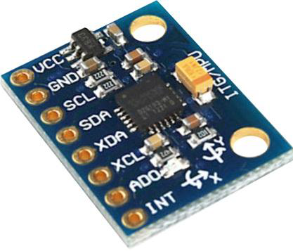

Fig 2.2: MPU 6050 Accelerometer Gyroscope module.

There are three push buttons in the wearable band which are specified for each function. First button is used for controlling hand, second for leg and third for fingers. The last one is a switch which is used to determine which side either right or left is to be controlled in the case of hand and finger. The signals from MPU6050 and switches are filtered and processed in MSP430G2553 microcontroller to form certain sequence which is characterized by the features of the gesture motions. For example “HLU0” means the left hand have to be move upward for certain amount of degree.”L0F0” means leg has to be moved to front for certain distance.

The RF transmitter transmits encoded signals at a frequency range of 2.5GHz also communicate serially with microcontroller with a baud rate of 9600b/s. The wearable band also consists of a 9V battery and a voltage regulator that regulates the voltage at 5V for RF transmitter and MPU6050 and at 3.3V for microcontroller. The transmitted signals are received by RF receiver kept inside the robot. The receiver receives the signals at a frequency of 2.5GHz and gives serially it to TM4C1294XL for further decoding.

**2.2 Bluetooth control**

Bluetooth is a wireless technology in short-range communication systems that aim to replace cables connecting devices. The Bluetooth control system is used for speech recognition and for the robot control. An android application was so developed for this. In this application there are various buttons for different controls as shown in fig 2.2. This app can be used for controlling of robot as well as the trainning of the robot. When each button is pressed, some keywords are generated and are transmitted to robot via bluetooth.

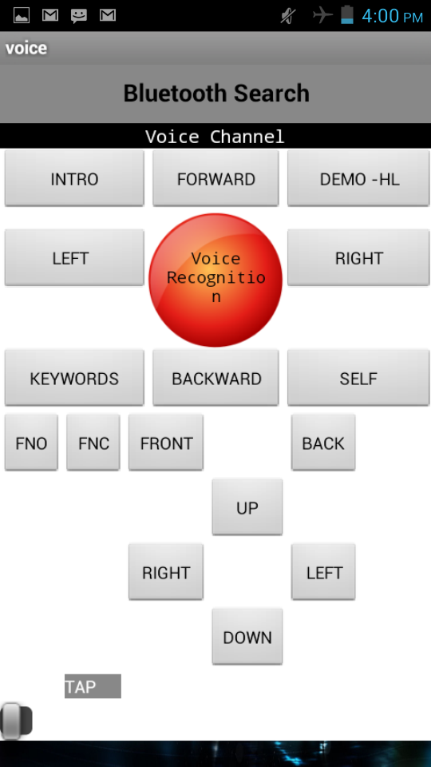

Fig 2.3: Android Application

There is a voice recogination section in the application. The voice signal from the trainer is recognised by the smartphone when the ‘voice recogination’ button is pressed. This audio file is converted to *flac* format and sends to Google servers using voice API and the corresponding text is returned by smart phone. This string response is send to the robot via Bluetooth. There is also a provision for the user to type the commands or the text messages in the command box provided in the application. The signals from the smart phone are received using a Bluetooth receiver HC-05. The received signals are then given to the TM4C1294XL serially for further process. A 5V supply is required for the Bluetooth receiver module.

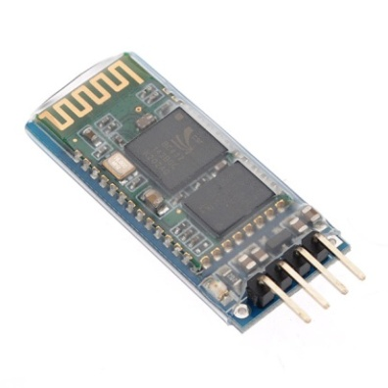

Fig 2.4: HC06 Bluetooth module

**2.3 Sensor Units**

2.3.1 Ultra Sonic Sensor

Ultrasonic sensors are [transducers](http://en.wikipedia.org/wiki/Transducer) that convert [ultrasound](http://en.wikipedia.org/wiki/Ultrasound) waves into [electrical signals](http://en.wikipedia.org/wiki/Signal_(electrical_engineering)) or vice versa. Those sensors that can able to transmit and receive are also called as ultrasound transceivers; many ultrasound sensors besides being [sensors](http://en.wikipedia.org/wiki/Sensor) are indeed transceivers because they can both sense and transmit. The Ultra sonic sensor identifies any one in front of the robot and gives an introduction about it.

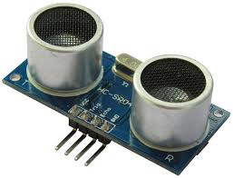

Fig 2.5: HC-SR04 Ultrasonic Sensor

An ultrasonic wave is transmitted from the ultrasonic sensor in a periodic manner. The echo is received by the sensor. The time required for the ultrasonic wave to come back is calculated. By checking this time period, the robot identifies whether there is any object in front of it. The controlling of ultrasonic sensor is done from TM$C1294XL microcontroller unit. A 5V supply is required for the operation of the sensor.

2.3.2 Temperature and humidity sensor

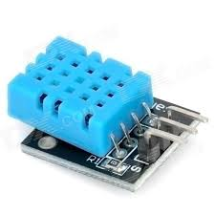

Fig 2.6: DHT11 Temperature Sensor

In order to check the temperature and the humidity level inside the robot, a temperature and a humidity sensor DHT11 is placed inside the robot. The signal from DHT11 is processed in TM4C1294XL microcontroller unit. The values of the temperature in 0C and humidity in % are displayed in the display screen. The sensor takes the readings in every 800 milliseconds. The temperature and humidity sensor requires a 5V supply to operate.

2.3.3 Audio Sensor

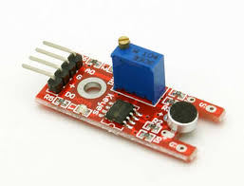

Fig 2.7: Audio Sensor

The audio sensor senses the audio signals from the speaker. If there are sound signals from the speaker, then the audio sensor generates a high voltage. Else if there are no audio signals from the speaker, then the sensor generates a zero voltage. These signals are then processed for controlling the movements of the lips. The audio sensor is calibrated in order to neglect small voices or noises.

2.3.4 Variable pot

The degree of accuracy can be adjusted by using a variable pot in the robot. Degree of accuracy means the minimum degree of rotation of angle of servomotors. It can be done at the time of training of robot.

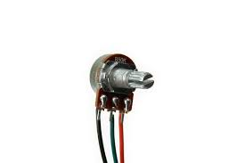

Fig 2.8: Variable pot

**2.4 Data Acquisition**

The central part of the data acquisition unit is the TM4C1294XL which is a 120MHz microcontroller unit. The TM4C1294Xl has multiple TX-RX pins for multiple serial communications. Tiva™ C Series microcontrollers integrate a large variety of rich communication features to enable a new class of highly connected designs with the ability to allow critical, real-time control between performance and power.

The inputs from the Bluetooth receiver and RF receiver are taken into the TM4C by serially and the data from temperature and humidity sensor, ultrasonic sensor, audio sensor and pot is read by the digital pins of TM4C. These inputs are then filtered in this unit and are given to the Beagle board XM in serial manner via USB.

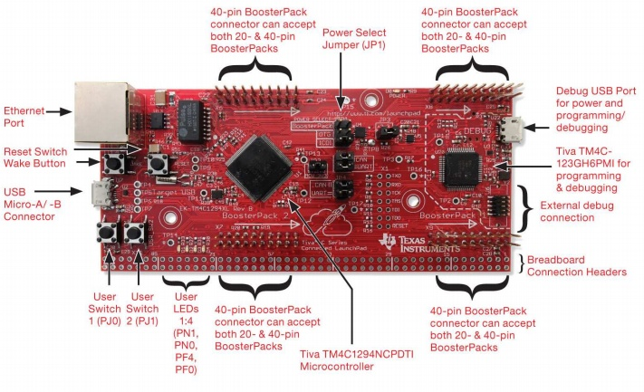

Fig 2.9: TM4C1249XL

The Tiva™ C Series TM4C1294 Connected Launchpad Evaluation Board is a low-cost evaluation platform for ARM® Cortex-M4-based microcontrollers. The Connected Launchpad design highlights the TM4C1294XL microcontroller with its on-chip 10/100 Ethernet MAC and PHY, USB 2.0, hibernation module, motion control pulse-width modulation and a multitude of simultaneous serial connectivity.

TM4C1294XL MCU has 120MHz 32-bit ARM Cortex-M4 CPU with floating point, 1MB Flash, 256KB SRAM, 6KB EEPROM, Integrated 10/100 Ethernet MAC+PHY, data protection hardware, 8x 32-bit timers, dual 12-bit 2MSPS ADCs, motion control PWMs, USB H/D/O, and many additional serial communication interfaces. It is composed of Dual, stackable Booster Pack XL connection sites.

The main algorithm of TM4C1294XL for taking the inputs is given below:

* Trigger the ultrasonic sensor.
* Check for echo signal.
* If echo is received then calculate the distance.
* If the object in front of it is less than 50cm then it says “HELLO”.
* If the object is less than 20cm then it gives an introduction about it.
* Check whether Serial4 buffer is available.
* If it receives input from Bluetooth receiver, then it writes serially that data to the processor.
* Check whether Serial7 buffer is available.
* If it receives the input from RF receiver, then it decodes the sequence and it writes serially to the processor.
* Check whether there is any signal from the audio sensor.
* If there is any signal from audio sensor, then it gives signal to the MSP430 microcontroller that controls the lip movements.
* Check the inputs from temperature and the humidity sensor.
* Convert the temperature readings to 0C and humidity readings to %.
* Send these data to display unit.
* Repeat the steps.

**CHAPTER 3**

**DATA PROCESSING**

Data processing Unit consist of Beagle board XM as the central processing unit. Data from the data acquisition unit is send to CPU and after processing, the data is passed to data execution unit for the execution. In AIHRO, Beagle board XM is used as power supply unit and can talk to both TM4C’s via USB cable.

Fig 3.1: Data processing unit.

**3.1 Beagle board XM**

The Beagle Board-XM is a 8.25×8.25 cm board, powered by an ARM Cortex A8 CPU and relying on 512MB of RAM. It features, among other things, a micro SD slot, a serial port, an Ethernet port, an HDMI output, an S-Video port, 4 USB-A ports, 1 mini USB OTG port and stereo input/output. There is basically all you need to build a simple desktop computer. Just plug in a USB keyboard, a USB mouse, an RJ-45 wire and your HDMI wire and boot it. Here use a regulated 5V 3Amps DC power supply to power the beagle board. Unlike MCU’s such as the PIC, NetDuino, these run a full OS (usually Linux or Android). They do however feature some of the same low level interfaces like GPIO, I2C, SPI, etc. The Beagle Board has a nice size-to-power ratio and still supports the ubiquitous ARMv7 architecture.

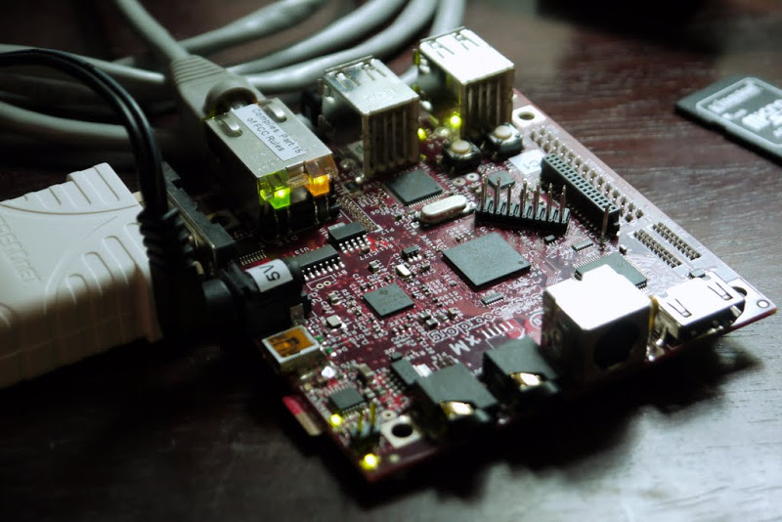

Fig 3.2: Beagle board XM

**3.2 USB HUB**

A USB hub is a device that expands a single Universal Serial Bus (USB) port into several so that there are more ports available to connect devices to a host system. A bus-powered hub is a hub that draws all its power from the host computer's USB interface. It does not need a separate power connection. However, many devices require more power than this method can provide and will not work in this type of hub. A USB's electric current is allocated in units of 100 mA up to a maximum total of 500 mA per port. Therefore a compliant bus powered hub cannot have more than four downstream ports and cannot offer more than four 100 mA units of current in total to downstream devices (since the hub needs one unit for itself). If a device requires more units of current than the port it is plugged in can supply, the operating system usually reports this to the user. In contrast, a self-powered hub is one that takes its power from an external power supply unit and can therefore provide full power (up to 500 mA) to every port. Many hubs can operate as either bus powered or self powered hubs. Dynamic-powered hubs are hubs, which can work as bus-powered as well as self-powered hubs. They can automatically switch between modes depending on whether a separate power supply is available or not. While switching from bus-powered to self-powered operation does not necessarily require immediate renegotiations with the host, switching from self-powered to bus-powered operation may cause USB connections to be reset if connected devices previously requested more power than still available in bus-powered mode.

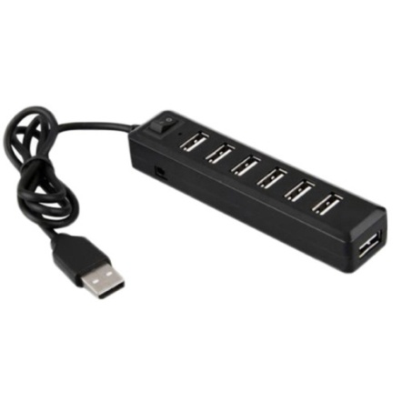

Fig 3.3: USB hub

**3.3 Interfacing of devices with CPU**

The connection of Beagle board XM with TM4c1294xl is done using micro USB cable. A USB hub is connected to CPU and tm4c-1 and tma4c-2 are connected to BBXM has also a 3.5mm audio jacket for the audio output. The audio amplifier is connected using 3.5mm jack audio cable. There is also a Wi-Fi receiver which is also connected to USB hub using USB cable.

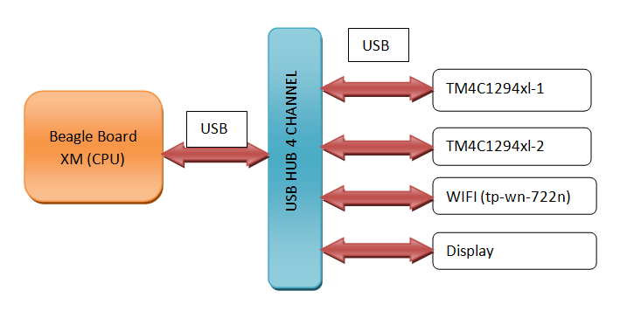

Fig 3.4: Serial communication with CPU

**3.4 Serial communication**

Serial communication just means that only one bit of information is sent a time. Lots of devices communicate serially, but usually the protocol RS-232 is what is implied when talking about serial ports and communication. Most computers don't have serial ports, but use a USB-to-serial driver to send and receive serial communication over USB. This is how the TM4C1294xl communicates with the CPU. The board comes with ICDI (In-circuit Debug Interface) which provides a virtual serial port, through which we can communicate with the target processor. We can interface the processor by connecting to this virtual serial port.

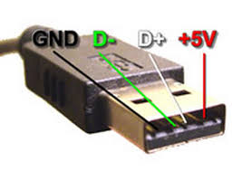

Fig 3.5: Serial communication port

The process of using the virtual serial communication port that is available within the In-Circuit Debug Interface (ICDI) on the Texas Instruments EC-TM4C1294GXL Launchpad board. The ICDI virtual serial port is hardwired to the RX and TX pins of UART0 of the target TM4C1294 processor on the Launchpad. In general, the user must initialize and configure the UART as well as the GPIO pins for RX0 and TX0. The general steps required are:

* Enable the clock to GPIO Port A
* Configure the function of the RX and TX pins
* Enable the clock to UART0
* Disable UART0 itself
* Configure the baud rate, word length, stop bit, and parity
* Enable UART0

3.4.1 Send Serial Data from the TM4C1294xl

To send data over the serial port on the TM4C1294xl, use the Serial object to start the serial communication at a particular baud (rate of data). 9600 is usually the baud used unless otherwise indicated. But in AIHRo we used to communicate at baud rate 19200 since it is faster and have reduced error rate. Once the Serial object has started, then the *println* and *print* methods are used to print information to the serial port. Println includes a line break at the end of data while print does not. It is important to note that the baud rate should be same of both devices which communicate over USB.

3.4.2 Receive Serial Data from the TM4C1294xl

To receive serial data, start the serial connection using serial begin, then set the baud rate. Then inside loop (), check if any serial data has arrived. If data has arrived and is available, store that data for execution. When serial data is sent out from the CPU, it is not sent to a particular device. For communication the baud rate should be same.

One of the problems with multiple serial communications is that whatever is listening to a serial port connected to the beagle board serial port will receive the messages. So it is necessary to identify the devices and corresponding ports. To solve this problem here define *udev* rule for each devices. Even though the devices are same and each will have a unique id i.e. product id, vendor id etc. So whenever the device with this product id is connected to CPU, the udev rule maps the device to a predefined port and name.

3.4.3 Execution of udev rule:

ACTION=="add", ATTRS{idVendor}=="0403", ATTRS{idProduct}=="6001", SYMLINK+="acqdata"

In Ubuntu the virtual serial port can be obtained by using the following command.

Command :dmesg | grep tty

ubuntu@arm:~$ dmesg | grep tty

[ 0.000000] console [tty0] enabled

[ 0.511813] serial8250: ttyS0 at I/O 0x3f8 (irq = 4) is a 16550A

[ 0.976561] 00:06: ttyS0 at I/O 0x3f8 (irq = 4) is a 16550A

[19119.869384] cdc_acm 3-1:1.0: ttyACM0: USB ACM device

[19286.543193] cdc_acm 3-1:1.0: ttyACM0: USB ACM device

[19334.903169] cdc_acm 3-1:1.0: ttyACM0: USB ACM device

[19492.879205] cdc_acm 3-1:1.0: ttyACM0: USB ACM device

[19520.655216] cdc_acm 3-1:1.0: ttyACM0: USB ACM device

[19638.703224] cdc_acm 3-1:1.0: ttyACM0: USB ACM device

[22003.135494] cdc_acm 3-1:1.0: ttyACM0: USB ACM device

[22016.279481] cdc_acm 3-1:1.0: ttyACM0: USB ACM device

[22031.903482] cdc_acm 3-1:1.0: ttyACM0: USB ACM device

From this data it is known that the serial port is /dev/ttyACM0 in cpu. The device details can be obtained by running the command

udevadm info -a -p $(udevadm info -q path -n /dev/ttyACM0) .

**3.5 Wi-Fi Module**

Wireless N USB Adapter TL-WN722N is used to connect the CPU to a wireless network and access high-speed Internet connection. Complies with IEEE 802.11n and it provide wireless speed up to 150Mbps, which is beneficial for the faster response from data-mining. Also, wireless security encryption could be established simply at a push of QSS (Quick Setup Security) button, preventing the network from outside threats.CPU can wirelessly programmed using this wifi module using a secure shell (SSH). AIHRo can also be controlled and monitored using SSH. A python program checks for the availability of Wi-Fi in every minutes and connects automatically if available.

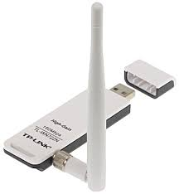

Fig 3.6: Wi-Fi Module

**3.6 Display**

This TFT LCD Screen Module has 40pins interface. The LCD in the board is 240374PQ. It is a 65K color, 400*240 (resolution), ILI9327 8 bit chip, 3.5 inch TFT LCD screen. The LCD has a wide viewing angle; the contrast is also very suitable. The Screen include a controller SSD1289, it supports 16bit data interface, easy to drive by many MCU's like STM32, AVR and 8051. The TFT01_3.5 layout a 40 pins interface for the project, the interface include LCD bus, SD card bus, Touch screen bus and the Flash bus. LCD TFT01 Arduino Mega Shield v1.2 .The TFT01 LCD module is work in 3.3V voltage level.

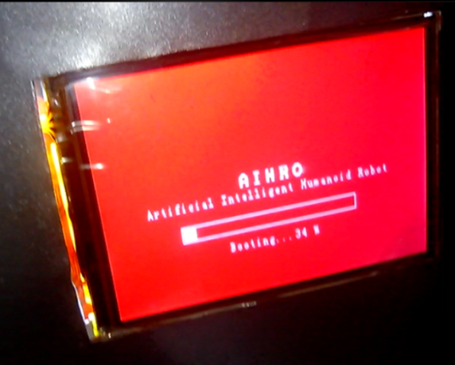

Fig 3.7: TFT LCD Display

**3.7 Audio System:**

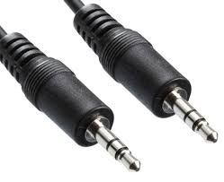

Fig 3.8: Audio cable

The audio from the beagle board XM is connect to an audio amplifier using 3.5mm audio aux cable. Since the audio out from beagle board is not enough to sound the speakers. The supply required for audio amplifier is taken from the battery (12v). Two speakers are used for the audio output. An audio sensor is also connected to one of the speaker, which controls the lip synchronization. So whenever the speaker sounds the jaw movement also activated.

**3.8 Training for a Task**

Training the robot for a new task is initiated when a “learn” command is received. After initiating the robot in training mode central processing unit BBXM request the sequence in every two seconds, if there is no input from input controller TM4C-1, it assumes the input as a 2 second delay by generating a sequence code “9999” and continue requesting data. The received control sequences and generated delay data is stored temporarily in the local memory for processing. It continues until an “end” command is received. Given below the sample of a combined input control sequence and generated delay sequence which is stored in the temporary local memory for processing.

* 11511251125112519999111111111999914111411241

This sequence is split into four digit individual control sequences.

That is 1151, 1251, 1251, 1251, 1111 etc.

First digit in the sequence identifies whether it is hand or leg using the first digit. That is 0 for leg and 1 for hand.

ex: 1151 -> Hand

Second digit represents the right or left motion 1 for left and 0 for right.

ex: 1151 ->Left

Third Digit represents the motor number

ex: 1151 -> motor number 5 is activated

Fourth digit indicates the finger movement.

From the control sequence similar individual sequences are grouped to generate a simplified new sequence which is in the form @5, 20; @7, 15;@3, 25; etc. In the Beagle board each motor direction is assigned with unique identification number ranges from 1 to 24.

@5-> represents the motor direction number.

20-> is the angle which should be adjusted from current position.

The main advantage of modifying the sequence is that, it smoothens the hand motion to provide flexible hand movements and the storage required to store a task is minimum. The new generated sequence is stored in the mysql database corresponding to its task name using python scripting language.

**3.9 Execution of task (Previously trained)**

When the processor receives “do” command followed by the task name, It searches for the task name in the mysql database. The control sequence corresponds to the task name is provided to the tm4c execution unit for further processing. If the search didn’t find the task name, then an audio message is given to the user.

**3.10 Apache web server**

Apache is the most commonly used Web Server on Linux systems. Web Servers are used to serve Web Pages requested by client computers. The most common protocol used to transfer Web pages is the Hyper Text Transfer Protocol (HTTP). Protocols such as Hyper Text Transfer Protocol over Secure Sockets Layer (HTTPS), and File Transfer Protocol (FTP), a protocol for uploading and downloading files, are also supported. Apache Web Servers are often used in combination with the MySQL database engine, the Hypertext Preprocessor (PHP) scripting language, and other popular scripting languages such as *Python* and *Perl*. This configuration is termed LAMP (Linux, Apache, MySQL and Perl/Python/PHP) and forms a powerful and robust platform for the development and deployment of Web-based applications.

Apache Http Server also called as Apache is a web server drafted in C language. It is open source software and cost of using it is zero. As it is a web Application Apache is the best option for deploying the application on web server as it widely used and having large active community working on development of it. It supports many server side scripting languages like perl, php, python. As python is extensively used in the ChittiBOT. Apache is optimal choice to provide.

**3.11 Artificial Intelligent Markup Language (AIML)**

Artificial Intelligent Markup Language (AIML) is the markup language that enables AIHRo based on A.L.I.C.E to communicate with humans. AIML describes a class of data objects called AIML objects and partially describes the behavior of computer programs that process them. AIML objects are made up of units called topics and categories, which contain either, parsed or unparsed data. Parsed data is made up of characters, some of which form character data, and some of which form AIML elements. AIML elements encapsulate the stimulus-response knowledge contained in the document. Character data within these elements is sometimes parsed by an AIML interpreter, and sometimes left unparsed for later processing by a responder. It was developed by Dr. Richard Wallace and followed by other likeminded programmers (AIML free software community). An A.L.I.C.E. ("Artificial Linguistic Internet Computer Entity") AIML tag set was released under GNU General Public License (GPL).

AIML (Artificial Intelligence Markup Language) contains a simple yet powerful XML markup tag called <srai>. "Symbolic Reduction Artificial Intelligence", "Syntactic Rewrite AI", "Simple Recursive AI", and “Stimulus-Response AI"--this tag has many acronyms. Yet the meaning of the markup <srai>X</srai> is simple: The <srai> tag always appears in the response template, but the robot treats X just like an input to the robot. The robot scans through its memory and finds the best response for X. The only tricky part is, the response to X may itself contain more <srai> tags.

3.11.1 Recursive Response

The best way to understand the recursive action of the AIML <srai> tag is by example.

Robot: You may say that again Alice.  
Robot: Once more? "That."

The robot has no specific response to the pattern "You may say that again Alice." Instead, the robot builds its response to the client input in four steps. This simple sentence activated a sequence of four categories linked by <srai> tags. The robot constructed the reply "Once more?’That'" recursively as each sub sentence triggered the next matching pattern. In this example the processing proceeds in four steps, because each of the first three steps evokes another symbolic reduction.

Table 3.1: data processing in AIML

|  |  |  |  |  |
| --- | --- | --- | --- | --- |
| **Step** | **normalized input** | **matching pattern** | **template** | **Response** |
| 1. | YOU MAY SAY THAT AGAIN ALICE | _ <name/> | <sr/> |  |
| 2. | YOU MAY SAY THAT AGAIN | _ AGAIN | Once more? <sr/> | Once More? |
| 3. | YOU MAY SAY THAT | YOU MAY * | <sr/> | Once More? |
| 4. | SAY THAT | SAY * | "<person/>" | Once More? "that". |

In step 1, the patterns with "_" match first because they are last in alphabetical order. The order of the matches depends on this alphabetical ordering of patterns. ALICE always matches suffixes with "_" before prefixes with "*". Whatever matches either wild-card symbol becomes the value of <star/>.

Steps 1 through 3 illustrate the common AIML templates that use the abbreviated <sr/> tag. (Remember, <sr/> = <srai><star/></srai>). The categories with the patterns "_ <name/>" and "YOU MAY *" simply reduce the sentence to whatever matches the "*", as illustrated by steps 1 and 3. Some AIML templates in ALICE combine the <sr/> with an ordinary text response, as step 2 with the pattern "_ AGAIN". The phrase "Once more?" becomes part of any reply ending in "AGAIN".

The most common use of <srai> is to map two, or more, patterns to the same response:

<category>  
    <pattern>P</pattern>  
    <template>  
        <srai>Q</srai>  
    </template>  
</category>  
<category>  
    <pattern>Q</pattern>  
    <template>R</template>  
</category>

An input matching either pattern, P or Q, gets the same response R.

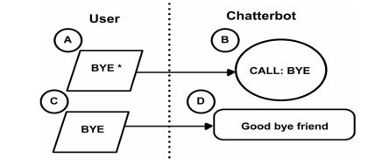

Fig 3.9: Pattern Matching

3.11.2 Symbolic Reductions and State

The tag <that> in AIML introduces one dimension of "dialogue state" into the robot response. The value of <that> is whatever the robot said before that provoked the current client input.

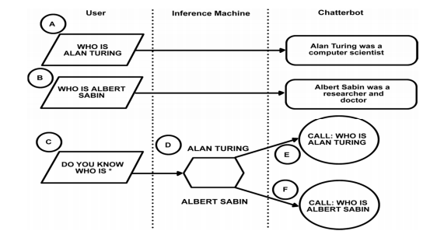

Fig 3.10: Symbolic Reductions and State

**3.12 Python**

Core technology used here is python. It Serves as server side scripting language and is the heart of whole system. It takes input query and processes it to produce the output. Python is cross platform language so can be easily ported between different platforms.

**3.13 CGI**

CGI stands for Common Gateway Interface is a method used by web server and server side programs to interact with each other. It can be written using any scripting language such as Python, Perl, TCL etc and it resides on web server. CGI scripts are evoked by web server to process data generated by web browser at client side. CGI is highly portable i.e. if written for one web server can be used on other server provided by different vendor without doing any changes in the existing one.

**CHAPTER 4**

**DATA EXECUTION UNIT**

Data execution is the process of collecting the sequence from the processor and converts it into an executable form. The components of data acquisition systems include:

* A central unit that collects the sequence from the processor.
* Decoder decodes the sequences.
* Digital to analog converters that converts the digital data to analog form.

The various outputs from the AIHRo are through data execution unit. The block diagram of the data acquisition unit is given below.



Fig.4.1: Block diagram of Data Execution Unit

The sequences are read serially from the processor via USB by the TM4C1294XL in data execution unit. These sequence is the decoded in the microcontroller unit. The decoded data is the given to coressponding controllers for controlling servo motors.

**4.1 MSP430G2553 Microcontroller**

The Texas Instruments MSP430 family of ultra-low-power microcontrollers consists of several devices featuring different sets of peripherals targeted for various applications. The architecture, combined with five low-power modes, is optimized to achieve extended battery life in portable measurement applications. The device features a powerful 16-bit RISC CPU, 16-bit registers, and constant generators that contribute to maximum code efficiency. The digitally controlled oscillator (DCO) allows wake-up from low-power modes to active mode in less than 1µs.

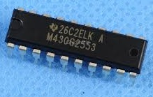

Fig.4.2: MSP430G2553 Microcontroller

The MSP430G2x13 and MSP430G2x53 series are ultra-low-power mixed signal microcontrollers with built-in 16-bit timers, up to 24 I/O capacitive-touch enabled pins, a versatile analog comparator, and built-in communication capability using the universal serial communication interface. In addition the MSP430G2x53 family members have a 10-bit analog-to-digital (A/D) converter.

**4.2 Servo Motors**

A servomotor is a [rotary actuator](http://en.wikipedia.org/wiki/Rotary_actuator) that allows for precise control of angular position, velocity and acceleration. It consists of a suitable motor coupled to a sensor for position feedback. It also requires a relatively sophisticated controller, often a dedicated module designed specifically for use with servomotors. They are not a specific class of motor although the term servomotor is often used to refer to a motor suitable for use in a closed-loop control system. Servomotors are used in applications such as [robotics](http://en.wikipedia.org/wiki/Robotics), [CNC](http://en.wikipedia.org/wiki/CNC) machinery or automated manufacturing. As the name suggests, a servomotor is a [servomechanism](http://en.wikipedia.org/wiki/Servomechanism). The input to its control is some signal, either analogue or digital, representing the position commanded for the output shaft.

The very simplest servomotors use position-only sensing via a [potentiometer](http://en.wikipedia.org/wiki/Potentiometer) and [bang-bang control](http://en.wikipedia.org/wiki/Bang-bang_control) of their motor; the motor always rotates at full speed (or is stopped). This type of servomotor is not widely used in industrial [motion control](http://en.wikipedia.org/wiki/Motion_control), but it forms the basis of the simple and cheap servos used for models. More sophisticated servomotors measure both the position and also the speed of the output shaft. They may also control the speed of their motor, rather than always running at full speed. Both of these enhancements, usually in combination with a [PID control](http://en.wikipedia.org/wiki/PID_controller) algorithm, allow the servomotor to be brought to its commanded position more quickly and more precisely, with less [overshooting](http://en.wikipedia.org/wiki/Overshoot_(signal)).

The servo motors are used for different hand and lip motions of AIHRo. For each hand there contains three servos and for the eye lid movements and the lip movements, there are separate servomotors. Pulse width modulation is used for the controlling the servo motors.

**4.3 DC Gear motor and H-bridge**

For base motions, two DC gear motors are used. These motors are controlled by a an H-Bridge cicrcuit,that have a current handling capacity of 20A. The signals to the H-Bridge is taken directly from TM4C1294XL in data execution unit. An H bridge is an [electronic circuit](http://en.wikipedia.org/wiki/Electronic_circuit) that enables a voltage to be applied across a load in either direction. These circuits are often used in [robotics](http://en.wikipedia.org/wiki/Robotics) and other applications to allow DC motors to run forwards and backwards. Most DC-to-AC converters ([power inverters](http://en.wikipedia.org/wiki/Power_inverter)), most [AC/AC converters](http://en.wikipedia.org/wiki/AC/AC_converter), the DC-to-DC [push–pull converter](http://en.wikipedia.org/wiki/Push%E2%80%93pull_converter), most [motor controllers](http://en.wikipedia.org/wiki/Motor_controller), and many other kinds of [power electronics](http://en.wikipedia.org/wiki/Power_electronics) use H bridges. In particular, a [bipolar stepper motor](http://en.wikipedia.org/wiki/Stepper_motor#Bipolar_motor) is almost invariably driven by a motor controller containing Two H Bridges.

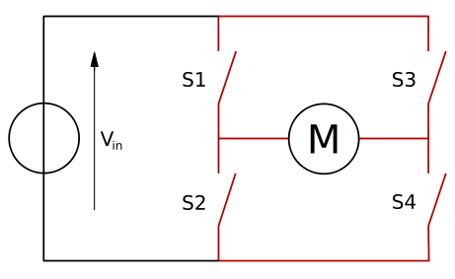

Fig.4.3: H-Bridge Circuit

The term H Bridge is derived from the typical graphical representation of such a circuit. An H bridge is built with four switches (solid-state or mechanical). When the switches S1 and S4 (according to the first figure) are closed (and S2 and S3 are open) a positive voltage will be applied across the motor. By opening S1 and S4 switches and closing S2 and S3 switches, this voltage is reversed, allowing reverse operation of the motor. Using the nomenclature above, the switches S1 and S2 should never be closed at the same time, as this would cause a short circuit on the input voltage source. The same applies to the switches S3 and S4. This condition is known as shoot-through.

The H-bridge arrangement is generally used to reverse the polarity/direction of the motor, but can also be used to 'brake' the motor, where the motor comes to a sudden stop, as the motor's terminals are shorted, or to let the motor 'free run' to a stop, as the motor is effectively disconnected from the circuit. The following table summarizes operation, with S1-S4 corresponding to the diagram above.

Table4.1: H Bridge operation

|  |  |  |  |  |
| --- | --- | --- | --- | --- |
| S1 | S2 | S3 | S4 | Result |
| 1 | 0 | 0 | 1 | Motor rotates right |
| 0 | 1 | 1 | 0 | Motor rotates left |
| 0 | 0 | 0 | 0 | Motor free runs |
| 0 | 1 | 0 | 1 | Motor brakes |
| 1 | 1 | 0 | 0 | Short power supply |
| 0 | 0 | 1 | 1 | Short power supply |
| 1 | 1 | 1 | 1 | Short power supply |
| 1 | 0 | 1 | 0 | Motor brakes |

**4.4 Working and Algorithm**

The sequence from the micro processor is decoded in the TM4C1294XL. Here it identifies whether the sequence represents the motion of left hand ,right hand, base motion or finger motion. Then it provides corresponding control words to the microcontrollers of respective hands serially. If the sequence represents motion of left hand, then it provides the control words to the microcontroller, that provides signals to the left hand servos via serial. Similarly it is same in case of right- hand and fingers.The control of base motion is done through the H-Bridge circuit. So the contol signals are given to the H-Bridge through the PWM pins.

When the control words are received in the microcontroller it identifies the directionof motion.If the control word represents the motion in upward direction or downward direction, then the controller provides signal to the servomotors at the joints that represents elbow joint in human hand. If the control word represents the motion in left side direction or right side

Fig.4.4: Data Execution Algorithm

direction, then the controller provides signal to the servomotors at the joints that represents glenohumeral joint in human hand. If the control word represents the motion in forward direction or backward direction, then the controller provides signal to the servomotors at the joints that represents acromioclavicular joint in human hand.The control signals for the fingers are provided from other microcontroller for the fingers.

**CHAPTER 5**

**MECHANICAL STRUCTURE**

**5.1 Mechanical structure**

The design and the fabrication of a cost effective and weightless stable mechanical structure is always a challenge in creating a Humanoid Robot. The mechanical body that is designed for AIHRO is really unique. The entire mechanical structure is made up of Aluminium. Aluminium provides the robot a stable and robust mechanical body with a minimized body weight. The precise and rigid movement of the joints are provided by the powerful servo motors. The bearing is used for free and easy movement of the robot hand joints. The C channels, angles and thin sheets are different Al materials used in the body structure. 1inch Rivets are used for the joints of different mechanical parts.

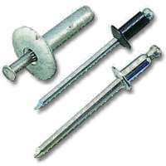

Fig 5.1Rivets

A rivet is a permanent mechanical [fastener](http://en.wikipedia.org/wiki/Fastener). Before being installed, a rivet consists of a smooth [cylindrical](http://en.wikipedia.org/wiki/Cylinder_(geometry)) shaft with a head on one end. The end opposite the head is called the tail. On installation the rivet is placed in a punched or drilled hole, and the tail is upset, or bucked (i.e., deformed), so that it expands to about 1.5 times the original shaft diameter, holding the rivet in place. To distinguish between the two ends of the rivet, the original head is called the factoryhead and the deformed end is called the shophead or buck-tail. However, it is much more capable of supporting shear loads (loads perpendicular to the axis of the shaft). Bolts and screws are better suited for tension applications

**5.2 Rivet Gun**

A rivet gun, also known as a pneumatic hammer is a type of [tool](http://en.wikipedia.org/wiki/Tool) used to drive [rivets](http://en.wikipedia.org/wiki/Rivet). The rivet gun is used on the manufactured head side of the rivet and a bucking bar is used on the buck-tail side of the rivet. The energy from the hammer in the rivet gun drives the work and the rivet against the inertia of the bucking bar. As a result, the tail of the rivet is deformed and hardened. At the same time the work is tightly drawn together and retained between the rivet head and the broadened and flattened tail. Nearly all rivet guns are [pneumatically powered](http://en.wikipedia.org/wiki/Pneumatics). Those rivet guns used to drive rivets in structural steel are quite large while those used in aircraft assembly are easily held in one hand. A rivet gun differs from an [air hammer](http://en.wikipedia.org/wiki/Air_hammer_(fabrication)) in the precision of the driving force.

Rivet guns vary in size and shape and have a variety of handles and grips. Pneumatic rivet guns typically have a regulator which adjusts the amount of air entering the tool. Regulated air entering passes through the throttle valve which is typically controlled by a trigger in the hand grip. When the trigger is squeezed, the throttle valve opens, allowing the pressurized air to flow into the [piston](http://en.wikipedia.org/wiki/Piston). As the piston moves, a port opens allowing the air pressure to escape. The piston strikes against the rivet set. The force on the rivet set pushes the rivet into the work and against the buck. The buck deforms the tail of the rivet. The piston is returned to the original position by a spring or the shifting of a valve allowing air to drive the piston back to the starting position.

**5.3 Structure design**

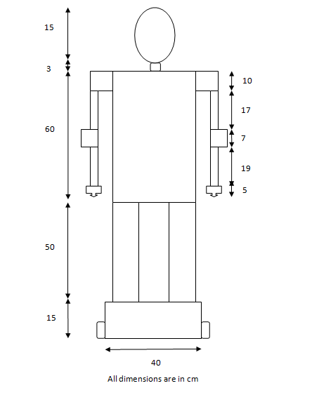

Fig 5.3: Mechanical structure of AIHRo

For actuation of different parts motors are used. Most of the motors are servomotors. For base movement DC geared motor is used. Servomotors are used for hand actuation. Six motors for each hand. Two motors are 33kg.cm which is placed at shoulder and 16 kg.cm motor is placed at the elbow. For fingers three 0.8kg.cm motors are used. These are placed in a triangular manner. Two servo motors, one for eye lid movement and other for jaw movement. 5kg.cm motors are used for performing this task.

# 5.4 Mega Torque Quarter Scale Servo Metal Gear

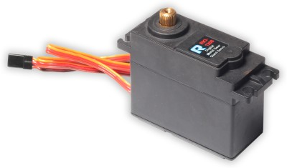

Fig 5.4: Mega Torque quarter scale servo metal gear

The servomotor is a quarter size motor with dual ball bearing and metal gears. This motor provides extreme torque of 27.5kg.cm at 4.8V and 33kg.cm at 6V. Their dimensions are 65.8*30.4*57.6(mm) and have a weight of199±1 (g). It has   6 metal gears and an angle limit of  210°±5°.The motor comprise of 2 ball bearing.  Output shaft is f8.5*25T. Complete series include 3 kinds of horns. Connector wire is of 22AWG*300mm±5 mm J style interface. Carbon-brush-motor is used with an operating voltage of 4.8-6.0 Volts. Statical current (at Stopped) 4.8V is 12.0mA±20% and statical current (at Stopped) 6V is ±16.0mA±20%. Operating speed when operated at 4.8V is 0.30sec/60 degrees at no load and at 6.0V is 0.27sec/60 degrees at no load. Stall Torque at 4.8V and 6.0V is 27.5 kg/cm and 33 kg/cm respectively. Stall Current at 4.8V and 6V is 3± 0.6A and 3.8± 0.8A respectively. Command signal is pulse width modulated.  Digital Controller amplifier is used.

**5.5 Servo motor v0150**

V0150 has an operating voltage ranging from 4.8 to 6.0V. PWM Input Range  is about   Pulse Cycle 20±2ms, Positive Pulse 1~2ms. Its STD direction is  Counter Clockwise / Pulse Traveling 1500 to 1900µsec. Stall Torque  15 kg-cm (206.3   oz/in) at 4.8V,  16.1  Kg-cm (221.4  oz/in) at 6V.  Operating Speed is 0.18 sec/ 60° at 4.8V, 0.16 sec/ 60° at 6V at no load. Weight of servo is 56g (1.98 oz). 41.3*20.3*38.7*48.5*10. Special feature include heavy duty metal gears and it is an economic servo.

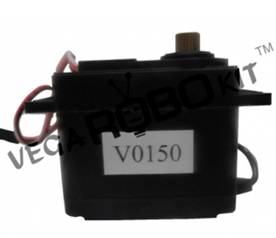

Fig 5.5: Servomotor V0150

# 5.6 10 RPM Side Shaft Super Heavy Duty DC Gear Motor

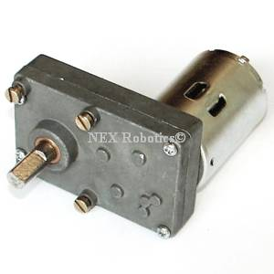

Fig 5.6: 10 RPM side shaft super heavy duty DC Gear Motor

10 RPM Side Shaft Super Heavy Duty DC Gear Motor is suitable for bigger robots / small automation systems. It has sturdy construction with large gears. Gear box is built to handle the stall torque produced by the motor. Drive shaft is supported from both sides with metal bushes. Motor runs smoothly from 4V to 12V and gives 10 RPM at 12V. Motor has 8mm diameter, 19mm length drive shaft with D shape for excellent coupling. Table below gives fairly good idea of the motor performance in terms of RPM vs. voltage at no load and that of stall torque at different voltages.

**5.7 Specifications**

The motor has an RPM of around 10 at the supply voltage of 12. The voltage range of the motor is about 4 to 12V. The stall torque is 106.08 Kg-cm at a stall current of 4.4Amp. The motor has its shaft diameter of 8mm and a shaft length of the range 25 to 30 mm. It has a gear assembly of the type spur. Carbon brushes are used. The motor has an overall motor weight of 480gms.

**5.8 0.8KG.CM SERVO**

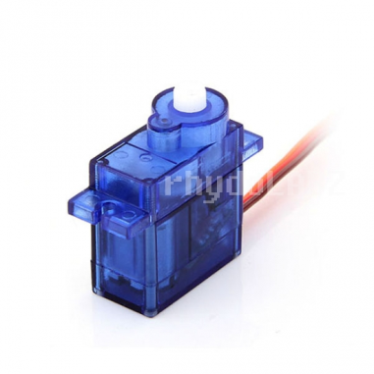

Fig 5.7: 0.8kg.cm servo

**T**he motor is a 0.8 Kg micro analog servo motor with plastic gear. The motor is light weighted and the operating voltage is 4.8V to 6V. The rotation scope of the motor is 120 degrees. The motor is mainly used in robotics applications. Dimensions of motor are 23.2 × 12.5 × 22 mm and have a weight of 9 gm. Its operating speed is 0.12sec/60degree at 4.8V and 0.10sec/60degree at 6V. Stall Torque of 0.8 kg.cm/18.09 oz at (4.8V). Control System is Analog and direction is counter clockwise. Operating Angle is 120degree and required pulse ranges from 900us-2100us. Plastic gears are used.

The hand of robot is made up of Al channels. Motor holders were made and servos were placed in those holders. The shaft of motors was connected to the rest of the structure by using shaft couplers. Hand structure was designed based on our requirement in movement. Based on the load requirement these motors were selected. The palm was cut out from GI sheet with a structure similar to a triangle. At each corners servos are placed by using servo motor holders.

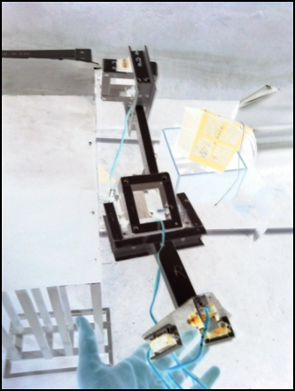

Fig 5.8: Structure of hand

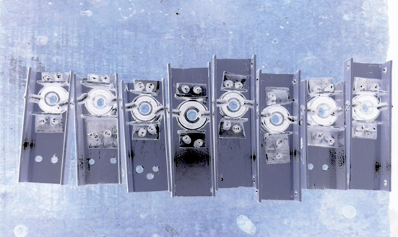

Fig 5.9: Bearing Holder

One of the major problems faced during construction of hand was that free movement of hand parts. For frictionless motion ball bearings were used. This makes the movement easier. Bearings were fitted to the c channels by using Al angles and rivets. The bearings should be carefully placed in order to avoid jerking during movement of hand. Bearings should be tightly placed. Six rivets are required for placing one bearing.

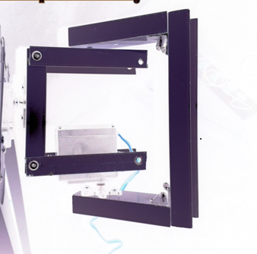

Fig 5.10: U-Clamps

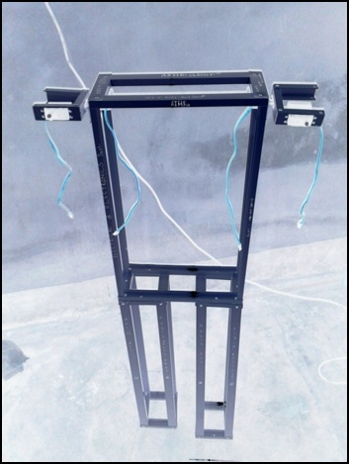

Fig 5.11: Basic mechanical structure of AIHRo

This figure shows the basic structure of AIHRo. Al is used to reduce the weight of robot. Working on Al is also easier as compared to other metals. C channels were cut out based on the required measurements. Then these pieces were joined to form the basic structure by using rivets. Rigid joints are made by using rivets.

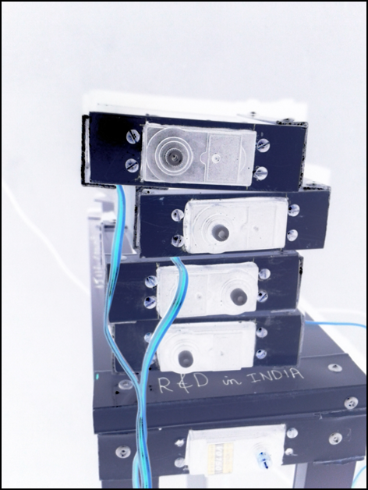

Fig 5.12: Servomotor Holder

Table 5.1: Upper body actuators

|  |  |  |  |
| --- | --- | --- | --- |
|  | Joint | Angle range | Torque |
| Hand | Finger | 0-90 | 0.8kgcm |
| Wrist | 0-180 | 6kgcm |
| Arm/Shoulder | Yaw | 45-105 | 33kgcm |
| Pitch | 20-140 | 33kgcm |
| Roll | 0-140 | 33kgcm |
| Elbow | Yaw | 20-160 | 16kgcm |

**5.9 HEAD**

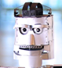

Fig 5.13: Structure of head

Head of AIHRo was similar to that of human. This robot has jaw movement and eye lid movement. For this two motors were used. These motors have a torque of 5kg.cm. The rotational motion of shaft of motor was converted into linear motion. This was done by coupling the shaft with rod or similar kind of material. These motors were placed in oval shaped GI sheets. Outer covering was made using Al sheets.

**CHAPTER 6**

**GESTURE RECOGNITION**

Today human-machine interaction is moving away from mouse and pen and is becoming pervasive and much more compatible with the physical world. With each passing day the gap between machines and humans is being reduced with the introduction of new technologies to ease the standard of living. Gestures have played a vital role in diminishing this abyss. Gestures can be captured with the help of an accelerometer, flex sensors, or by image processing. Gesture controlling techniques creates an environment for Human Machine Interaction (HMI). Humans can interact with machines naturally. Gesture control technique substitutes the common interfacing devices and minimizes the use of Graphic User Interfaces (GUI).

With the help of this technique one can do a hand gesture and corresponding to this notation, desired operation is performed by the machine. The movement of the accelerometer gives signals corresponding to the x, y, and z coordinates. This is then encoded and transmitted to the robot and the robot decodes it. Corresponding task is done by the robot according to the signal received. It can be used for doing a useful task. This method can also be exploited to extend their functionality. A gesture is any action that sends a visual signal to an onlooker. To become a gesture, an act has to be seen by someone else and has to communicate some piece of information to them. It can do this either because the gesturer deliberately sets out to send a signal.

**6.1 Gesture Recognition**

Gesture recognition is the process by which gestures made by the user are used to convey the information or for device control. In everyday life, physical gestures are a powerful means of communication. A set of physical gestures may constitute an entire language, as in sign languages. They can economically convey a rich set of acts and feelings. The primary goal of Gesture recognition is to create a system which can identify specific human gestures and use them to convey information or for device control. Interface with computers using gestures of the human body, typically hand movements.

The gesture recognition system used in AIHRo consists of two sections. First section is the wireless wearable gloves and second is on robot side. Gesture recognition is done using accelerometer and gyroscope module in the wearable band. An accelerometer is an electromechanical device that will measure acceleration forces. These forces may be static, like the constant force of gravity pulling at your feet, or they could be dynamic - caused by moving or vibrating the accelerometer. The block diagram of the gesture recognition system used in AIHRo is given below.

Fig 6.1: Block diagram of Gesture Recogination Unit

**6.2 Accelerometer and Gyroscope**

An accelerometer is a device that measures proper acceleration ("g-force"). Proper acceleration is not the same as coordinate acceleration (rate of change of velocity). For example, an accelerometer at rest on the surface of the Earth will measure an acceleration g= 9.81 m/s2 straight upwards. By contrast, accelerometers in free fall orbiting and accelerating due to the gravity of Earth will measure zero.

Accelerometers have multiple applications in industry and science. Highly sensitive accelerometers are components of inertial navigation systems for aircraft and missiles. Accelerometers are used to detect and monitor vibration in rotating machinery. Also it found use in tablet computers and digital cameras so that images on screen are always displayed upright. Accelerometers are used in drones for flight stabilization. Pairs of accelerometers extended over a region of space can be used to detect differences (gradients) in the proper accelerations of frames of references associated with those points. These devices are called gravity gradiometers, as they measure gradients in the gravitational field. Such pairs of accelerometers in theory may also be able to detect gravitational waves.



Fig. 6.2: Accelerometer

Single and multi-axis models of accelerometer are available to detect magnitude and direction of the proper acceleration (or g-force), as a vector quantity, and can be used to sense orientation (because direction of weight changes), coordinate acceleration (so long as it produces g-force or a change in g-force), vibration, shock, and falling in a resistive medium (a case where the proper acceleration changes, since it starts at zero, then increases). Micro machined accelerometers are increasingly present in portable electronic devices and video game controllers to detect the position of the device or for game input.

6.2.1 Principle of Accelerometers

An accelerometer measures proper acceleration, which is the acceleration it experiences relative to freefall and is the acceleration felt by people and objects. Put another way, at any point in space-time the equivalence principle guarantees the existence of a local inertial frame, and an accelerometer measures the acceleration relative to that frame. Such accelerations are popularly measured in terms of g-force.

An accelerometer at rest relative to the Earth's surface will indicate approximately 1 g upwards, because any point on the Earth's surface is accelerating upwards relative to the local inertial frame (the frame of a freely falling object near the surface). To obtain the acceleration due to motion with respect to the Earth, this "gravity offset" must be subtracted and corrections made for effects caused by the Earth's rotation relative to the inertial frame.

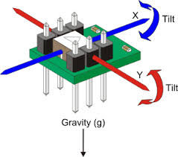

Fig.6.3: Accelerometer Structure

The reason for the appearance of a gravitational offset is Einstein's equivalence principle, which states that the effects of gravity on an object are indistinguishable from acceleration. When held fixed in a gravitational field by, for example, applying a ground reaction force or an equivalent upward thrust, the reference frame for an accelerometer (its own casing) accelerates upwards with respect to a free-falling reference frame. The effects of this acceleration are indistinguishable from any other acceleration experienced by the instrument, so that an accelerometer cannot detect the difference between sitting in a rocket on the launch pad, and being in the same rocket in deep space while it uses its engines to accelerate at 1 g. For similar reasons, an accelerometer will read zero during any type of free fall. This includes use in a coasting spaceship in deep space far from any mass, a spaceship orbiting the Earth, an airplane in a parabolic "zero-g" arc, or any free-fall in vacuum. Another example is free-fall at a sufficiently high altitude that atmospheric effects can be neglected.

However this does not include a (non-free) fall in which air resistance produces drag forces that reduce the acceleration, until constant terminal velocity is reached. At terminal velocity the accelerometer will indicate 1 g acceleration upwards. For the same reason a skydiver, upon reaching terminal velocity, does not feel as though he or she were in "free-fall", but rather experiences a feeling similar to being supported (at 1 g) on a "bed" of up rushing air. Acceleration is quantified in the SI unit m/s2, in the CGS unit gal (Gal), or popularly in terms of g-force (g).

For the practical purpose of finding the acceleration of objects with respect to the Earth, such as for use in an inertial navigation system, knowledge of local gravity is required. This can be obtained either by calibrating the device at rest or from a known model of gravity at the approximate current position.

**6.3 Switches**

There are three pushbuttons and one switch for specific functions. The first push button activates the control of the hand. Second push button selects controlling of the leg movements. The thrid for opening or closing the finger. The controlling is stopped till first two buttons are pressed simultaneously. The fourth one is a switch which determines whether right or left side is to be controlled. The buttons and switches are connected to the digital pins of the microcontroller.

**6.4 MSP430G2553 Microcontroller**

The Texas Instruments MSP430 family of ultra-low-power microcontrollers consists of several devices featuring different sets of peripherals targeted for various applications. The architecture, combined with five low-power modes, is optimized to achieve extended battery life in portable measurement applications. The device features a powerful 16-bit RISC CPU, 16-bit registers, and constant generators that contribute to maximum code efficiency. The digitally controlled oscillator (DCO) allows wake-up from low-power modes to active mode less than 1µs.



Fig.6.4: MSP430G2553 Microcontroller

The MSP430G2x13 and MSP430G2x53 series are ultra-low-power mixed signal microcontrollers with built-in 16-bit timers, up to 24 I/O capacitive-touch enabled pins, a versatile analog comparator, and built-in communication capability using the universal serial communication interface. In addition the MSP430G2x53 family members have a 10-bit analog-to-digital (A/D) converter.

**6.5 RF Transrecevier**

The sequence encoded by the microcontroller is transmitted from hand glove to the robot via RF waves. A RF transreceiver is used in the hand glove and one in robot. The transreceiver in the hand glove act as as the transmitter which transmits the sequence. The transreceiver in robot act as the receiver that receives the sequence. The module contains five pins. A 5v supply is given to the module through pins Vcc and GND. The signals from the microcontroller is received by module through the Rx pin serially. The data is transmitted from the module through Tx pin via RF. RST pin is used to reset the complete actions of the module.

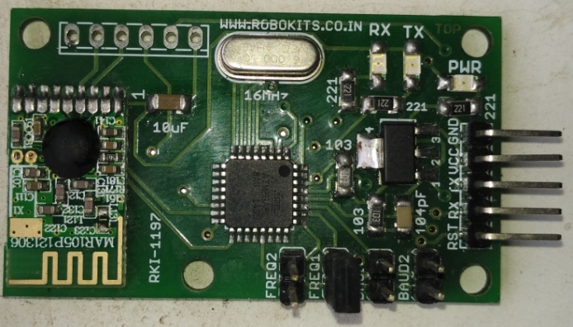

Fig.6.5:RF Transreceiver

The RX pin of the transreceiver inside the robot receives the RF signals and give these signals to the TM4C1294XL via TX pin in serial manner. The frequency used is 2.1 GHz and the baud rate used is 9600bits/second.

**6.6 Power Supply Unit**

The power for the operation of the complete hand glove module is tken from a 9V battery.The 9V supply is regulated to 5V and 3.3V. The 5V supply is used for the accelerometer and gyroscope module and for the RF Transreceiver. The 3.3V supply is used for the operation of the microcontroller. LM 317 is used for regulation purpose.

**6.7 Data Aqusition Unit**

The central part of the data acquisition unit is the TM4C1294XL which is a 120MHz microcontroller unit. The TM4C1294Xl has multiple TX-RX pins for multiple serial communications. Tiva™ C Series microcontrollers integrate a large variety of rich communication features to enable a new class of highly connected designs with the ability to allow critical, real-time control between performance and power. The sequence from the transceiver is received by the TM4C1294XL serially and through TM4c it is send to the microprocessor for further processing via serial.

**6.8 Werable Band**

The wearable band is the band that the trainer has to be wear.The whole module is fixed in this band and can be weared in the hand.

Flex sensor / switches

Accelerometer  
 +

Gyroscope

Transmitter

Micro controller unit

Fig.6.6: Wearable band

The wearable band that consists of an accelerometer gyroscope module MPU6050, microcontroller MSP430G2553, RF transmitter with 2.5GHz transmission frequency and voltage regulators. The MPU6050 detects the movements of the hand of the teaching person. It is a three axis accelerometer board. It produces three different analog voltages (x, y &z) in three dimensional motions according to the hand movement of the trainer. The MSP430G2553 is a low power microcontroller with 16MHz internal clock frequency. The MPU6050 communicates microcontroller with i2c protocols.

The signals from MPU6050 and switches are the filtered and processed in MSP430G2553 microcontroller to form certain sequence which is characterized by the features of the gesture motions. For example “HLU0” means the left hand have to be move upward for certain amount of degree.”L0F0” means leg has to be moved to front for certain distance.

**6.9 Algorithm**

Fig.6.7: Algorithm of Gesture Control

**6.10 Working**

The accelereometer and gyroscope produces certain values in range of (-20,000 to 20,000) for each directions of x,y and z according to the movement of the hand of the trainer. The accelerometer+gyroscope module communicate with the microcontroller using i2c protocols. The switches also have to be pressed for coreesponding control for the handleg and finger. The switches are connected to the digital pins of the mirocontroller. Using readings of from the switches and the accelerometer module, certain sequences are synthezised by the controller.

There are three pushbuttons and one switch for specific functions. The first push button activtes the control of the hand.Second push button selects controlling of the leg movements. The thrid push button opens or close the finger. The controllingis stopped till first two butions are pressed simultaneously. The fourth one is a switch which determines wether it is right or left side is to be controlled.

The sequence contains four characters. Each are encoded in such a way that the sequence entirely represents a motion of leg, hand or finger. The first character contains either the characters “H”,”L”or “0”. The letter H represents the sequence represents the motion of the hand, letter L repesents motion of Leg and the character 0represents the motion of the finger. The second letter constitues “R”,”L”,”0”. The charater R represents that the right hand or finger is in motion and letter Lreperesents left hand or finger is in motion. As the leg movement is using wheel, it doesot requires right or left sides. So for the leg motion,the second character is usally ‘0’.

The third character represents the direction of motion. If the third character is “U”,then it represents upward motion. If the third character is “D”,then it represents downward motion. If the third character is “F”,then it represents forward motion. If the third character is “B”,then it represents backward motion. If the third character is “R”,then it represents right side motion. If the third character is “L”,then it represents left side motion.For finger motion the third character is usally “0”. For leg motion the characters “U” and “D” is not used. The fourth character represents wether the fingeris open or closed.The character “0”reperesents the finger is closed and “1” reperesents finger is closed.

These encoded sequence are the given to the RF transreceiver module via serially and the transreceiver transmits the signals via RF. These RF signals are received by the receiver inside the robot and give it to the data aqusition unit serially. Here the sequence are decodedare give it to the micro processor via USB.

**CHAPTER 7**

**VOICE RECOGNITION**

The speech is recorded and translated to text output using GOOGLE API. The converted text is then send to the system side using a Bluetooth serial module. It receives the text and processed in the controller. The controller can be either MSP430/ATmega/PIC. The text output is then compared with predefined commands i.e. Commands for action. E.g. walk, forward, backward, etc for a humanoid. The controller either identifies the text output as command or as a normal talk. If it is a command then corresponding actions are taken in the controller else if it is a normal talk, then the text is passed to the MPU (Raspberry pi/Beagle Board). It is processed and best match response is converted into audio using the TTS engine. This audio output is fed to a speaker system.

**7.1 Block Diagram**

The generalized concept of this system consists of a voice recognition system, and response generating system.

7.1.1 User Side (Voice Recognition)

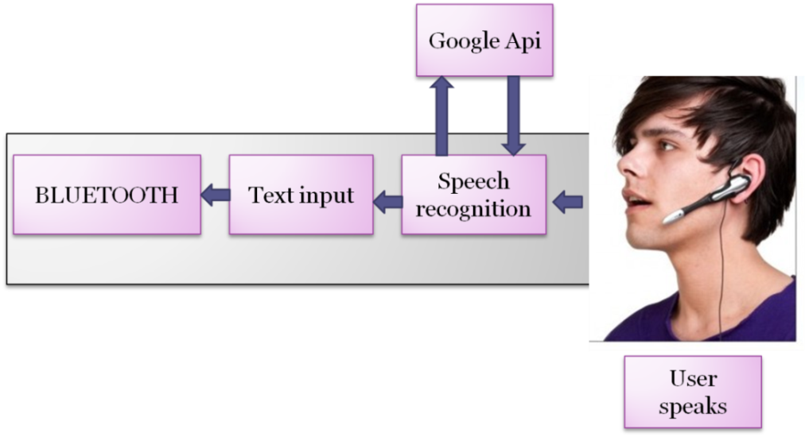

Smart phones/Tablets running on android platform

Fig 7.1: Block diagram of voice recognition system

7.1.2 System Side (Response Generating System)

This is the basic block diagram of the voice recognition and response generating system. First block is Bluetooth enabled device like smart phones and second block is the machine part. Speak from the user is recognized and converted to text using Google API (Audio file is converted to *flac* format and send to Google servers using voice API and the corresponding text is returned). This string response is send to the robot using a Bluetooth module.

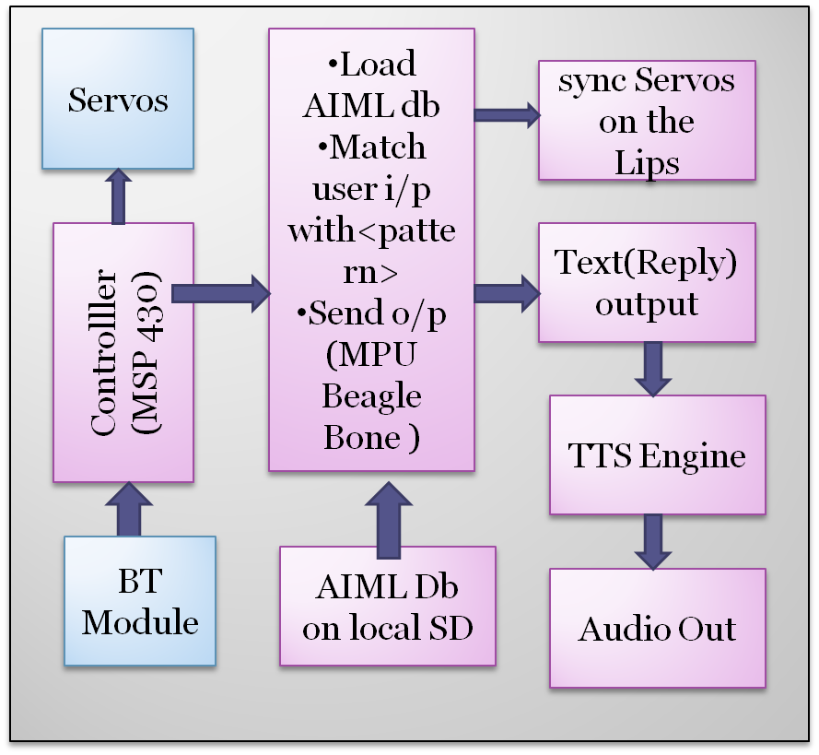

Fig7.2: Block diagram of response generating system (lips servos for humanoid)

At the machine side, received string is then identified as command or friendly talk. It is done by comparing with pre-coded commands in the controller. If it is a command, corresponding action is done using the servos else it is recognized as a friendly talk. If it is a friendly talk, the string is passed to MPU (Raspberry pi /Beagle bones) and response is generated from the AIML database. The output response is send to a TTS engine for the audible output and corresponding lip movement is done using servos placed on the lips for humanoids.

**7.2 Voice Recognition**

As an emerging technology, not all developers are familiar with speech recognition. The basic functions of both speech synthesis and speech recognition takes only few minutes to understand (after all, most people learn to speak and listen by age two), there are powerful capabilities provided by computerized speech that developers will want to understand and utilize.

Despite very substantial investment in speech technology research over last 40years, speech synthesis and speech recognition technologies still have significant limitations. Most importantly, speech technology does not always meet the high expectations of users familiar with natural human-to-human speech communication. One of the easiest implementation of speech recognition is using Google API. An android app which communicates using Google API can easily do the job.

7.2.1 Google API

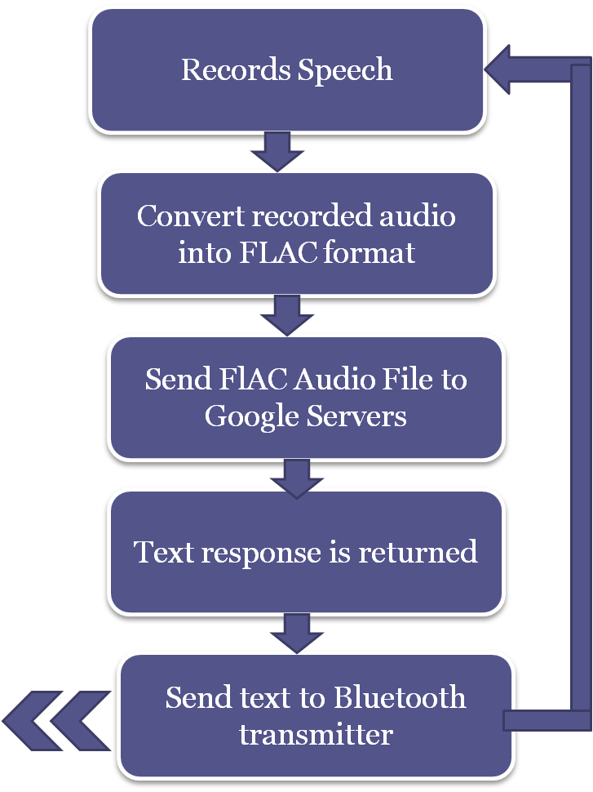

Fig 7.3: Voice recognition process

The Flow diagram shows the main processes which runs on the android smart phones/PDA/tablets etc. Speech recognition software records the speech in AAC format. The size of recorded file (AAC format) will be high. So in order to transfer it through web, the AAC format is converted into FLAC format which is highly compressed file format. Converted audio file is then processed and sent to Google servers. The spectrogram of audio is chopped up and sent to eight different computers housed in Google’s vast worldwide army of servers. It is then processed using the neural network models. After processing of the speech, it sends back the corresponding text for the audio signal to the Smartphone. After that the string output is send to inbuilt Bluetooth transmitter.

**7.3 Processing of Normal Chat**

The text string from the microcontroller is loaded and passed to apache web server. Python http urlib library is used for this purpose. String is passed to server using POST request to the php processing file. The input string is compared with the responses and using php, program pattern scanning is carried out. Best match response is then send to TTS engine (Text to speak) for the final audio output.

Fig 7.4: Processing of normal chat

**7.4 Pattern Matching in the Local Server**

The string received in the server is stored to a local character array and the program check for a best match pattern in the .brn files (brain files are files which consists of frequently and recently used pattern templates and responses). If there is a .brn files then interpret users input and apply pattern matching algorithm. The best match output response is send to TTS engine and the audio signal from audio jacket to an audio amplifier. The amplified output is fed to a speaker .if there is a no .brn file, then brain files are created from the aiml database stored in the sd memory and carried out the remaining processes.

Fig 7.5: Pattern matching

**7.5 Differentiate Between Voices and Commands**

Fig7.6: Identifying user input

The commands and normal talk is differentiated by the microcontroller unit. The received data from the Bluetooth receiver is fed to the microcontroller. There will be pre-coded commands stored either in the controller local memory or in SD card. These commands are compared with the received text string. If the string matches with a pre-coded command, then corresponding action is taken by activating the actuators using the control signals from controller. If it doesn’t match, then controller identifies it as a normal talk and passes the string to the microprocessor unit for processing.

**7.6 Processing of Voice Commands**

The input data which is recognized as command in processed in the data processing unit. Default voice commands are “LEARN”, “DO”, “STOP”,”FIND”.

LEARN: To initialize the robot in training mode.

DO: To execute a trained task. The command is provided along with the task name.

Example: DO TASK1

STOP: command to stop the training mode

FIND: command to initialize robot in data mining mode

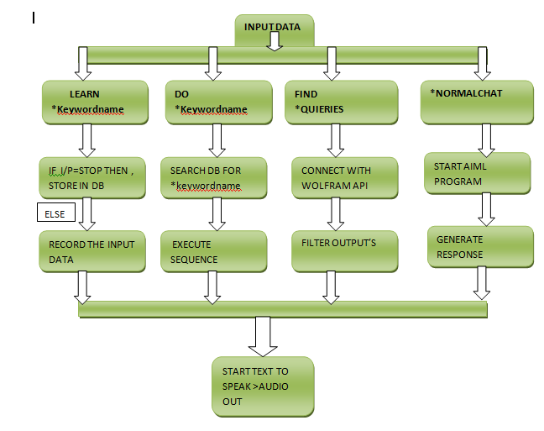

Fig 7.7: Algorithm of data processing

START TEXT TO SPEAK >AUDIO OUT

**CHAPTER 8**

**HARDWARE IMPLEMENTATION**

The hardware of entire robot is divided into three units based on its functions. They are,

* Mother board design
  + - Data acquisition unit.
    - Data processing unit.
    - Data execution unit.
* Power board design
* Gesture unit

**8.1 Motherboard design**

The main board consist of three units, data acquisition, data processing and data execution units which are interconnected using a USB hub. It also consists of three voltage regulators required to meet the board power. Indication lights are taken from different voltage channels for debugging. Main components used in motherboard design are,

* Voltage Regulators
* MSP430G2553 Controllers
* RF Receiver
* Bluetooth Receiver
* Indication Lights
* Ultrasonic sensor
* TFT Display
* USB HUB
* Condenser mic
* Analog to digital converter (for sound sensor)
* Connector wires
* Power channels

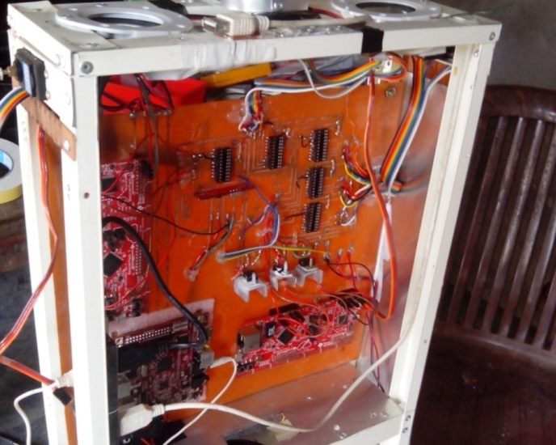

Fig 8.1: Mother board

**8.2 Power Board Design**

Power board consists of different voltage regulators, protection units and charging circuit. In AIHRo two types of voltage regulators are used. For continuous load i.e. beagle board xm (3A 5v) buck down converters which has higher efficiency (more than 90%). Linear voltage regulators are provided to meet the power of motor and other units. A linear regulator uses a transistor in series with the load and working in its linear region, like a potentiometer, and the power is regulated at the load by varying the transistor, that works like a potentiometer, by increasing the power in the transistor you reduce the power in the load, and by reducing the power in the transistor to increase the power at the load. That means that the element, the transistor consumes a lot of power. In the switching regulator the transistor is in series with the load, but now working in the open and saturation region, but to turn from one to another must pass the linear region for a very small time, which is the region of small consumption of energy.  
The switching regulator needs a filter to smooth the energy wave, DC, and an oscillator that provokes the switching. To increase the heat dissipation heat sink with heat paste is used along with two exhaust fans. Zener diodes are used for voltage protection and fuse for over current protection. Charging circuit consist of a bridge rectifier connected from a 5Amps transformer to charge the battery bank.

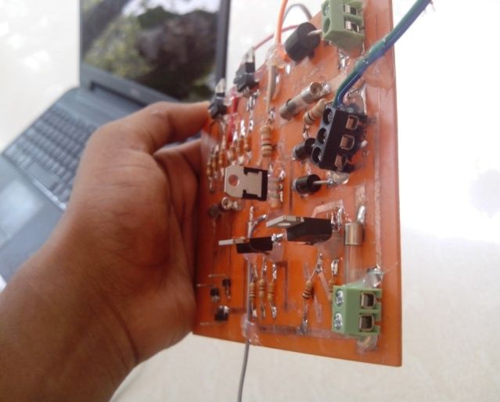

Fig 8.2: power board

**8.3 Battery Bank**

Two 12 volt 8 AH batteries are paralleled to meet the motor and the MPU loads also two 6v 4.5AH batteries are paralleled for the remaining loads. Parallel connections will increase the current rating, but the voltage will stay the same. Total battery bank outputs are 6v AH and 12v 16 AH.

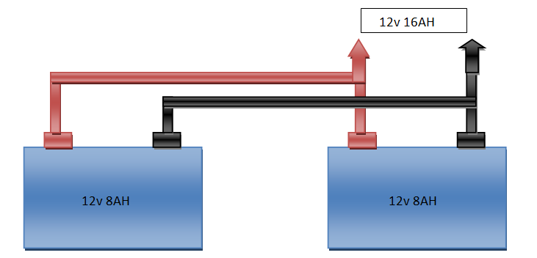

Fig 8.3: Battery bank

**8.4 Gesture Unit**

The gesture unit consists of a wearable band that the trainer has to wear in his hand. The wearable unit is composed of an accelerometer gyroscope module that detects the directions of motion, MSP430G2553 microcontroller for processing and encoding, RF transceiver that transmits the encode signals via RF. And there is a 9V battery that supplies power to entire wearable band unit with a voltage regulator. All these components are placed on printed circuit board.

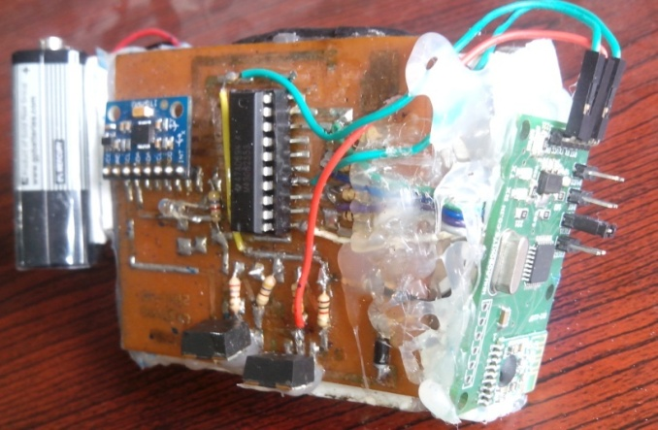

Fig 8.4 Gesture unit

**8.5 Final Hardware implementation**

Table 8.1 Overall specification of AIHRo

|  |  |
| --- | --- |
| Weight | 22kg |
| Height | 142cm |
| Moving speed | 0.04m/s |
| Grasping force | 0.85kg/finger |
| Actuator | Servomotor |
| Control unit | Data acquisition unit, Data execution, Data processing, Power unit, Sensor unit, Gesture etc |
| Sensors | 6axis imu MPU6050, Ultrasonic Sensor, Temperature, Humidity, Flex sensor |
| Power Bank | 12v 16AH, 6v 8AH |
| Operation Section | Laptop with Wireless LAN, Gesture, Smart phone with W LAN |
| Operating system | Ubuntu 12.04 |
| Degree of freedom | 12DOF |
| Connectivity | Bluetooth, Wi-Fi, RF |
| Charging | 8hr for full charge |
| Cooling unit | 2 exhaust fan |
| Display | 3.5” TFT Display |

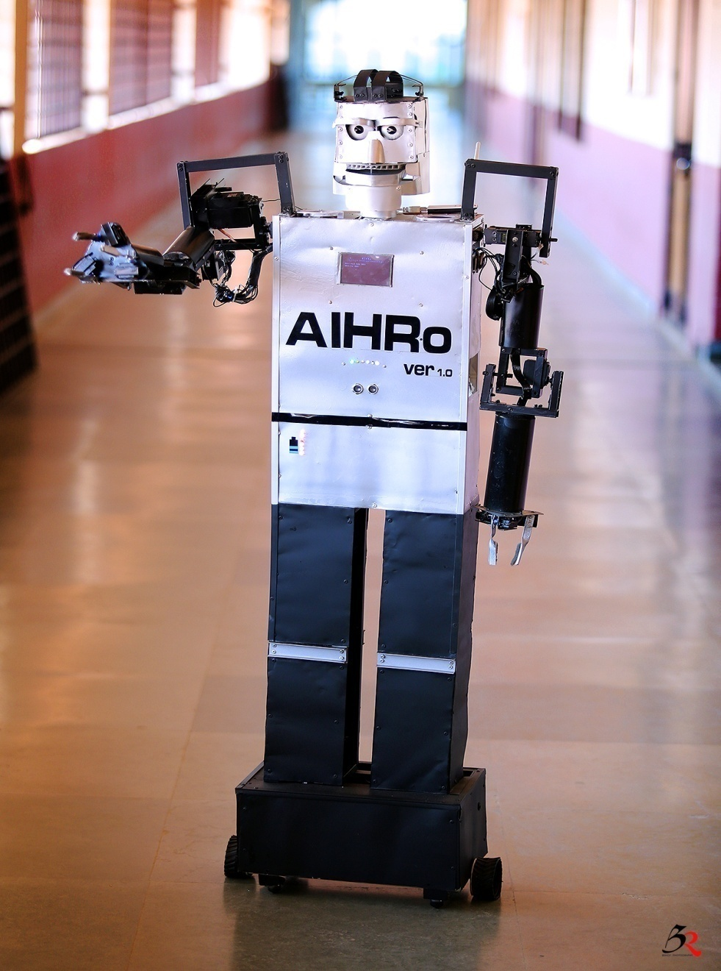

Fig: 8.5 complete working model of AIHRo

**CHAPTER 9**

**CONCLUSION**

The goal of the project was to implement a humanoid robot having the artificial intelligence that can learn a trained task and repeat it whenever needed with a command. The training the robot with a hand gesture and Bluetooth application is also aimed which is successfully implemented and the desired result is achieved. The entire robot is wirelessly controlled. It can be controlled through RF communication as gesture control. The Bluetooth is used for speech and the robot control. The entire communication and control of AIHRo can also be done using Wi-Fi. All these robot control methods are implemented very successfully. The talking of the robot is implemented which can generate desired response using AIML and data-mining making the robot very interactive.

AIHRo is an example of implementing the artificial intelligence to train the robot, which learn and repeat the task on demand at very low cost. This can also be implemented to the industrial robotics and other automation machines AIHRo is a project that is pioneering the future robot in the field of robotics engineering. In the future, implementing the video sensing and video recognition, AIHRo can perform task in wider application and is more reliable and in a better way. The movement of the robot is to be made Omni directional thus robot can move much easily in all directions.

**REFERENCES**

[1]Thomas Braunl,2003 “*Embedded Robotics: Mobile Robot Design and Applications with Embedded Systems”*, First Edition. Springer-Verlag, Berlin.

[2]J. Weizenbaum (1966), *“Eliza – a Computer Program for Study of Natural CommunicationBetween Man and Machine*”, Communications of the Association for Computing Machinery, vol.9, pp. 36-45.

[3]Jung-Yup Kim, Ill-Woo Park, Jungho Lee, Min-Su Kim, Baek-Kyu Cho and Jun-Ho Oh, *“System Design And Dynamic Walking Of Humanoid Robot KHR-2”*, IEEE International

Conference on Robotics & Automation, 2005.

[4]K. M. Lynch and M. T. Mason*. “Stable pushing: Mechanics, controllability, and planning. Int. Journal of Robotics Research”*, 15(6):533–556, 1996.